Software Design Document

Sydney Airbnb

Sabin Luitel (S5275468)  
Suzan Shrestha (S5279574)  
Ryan Chang Hee Kim (S5188533)

Table of Contents

1.0 System Vision 3

1.1 Problem Background 3

1.2 System Overview 3

1.3 Potential Benefits 3

2.0 Requirements 4

2.1 User Requirements 4

2.2 Software Requirements 4

2.3 Use Cases 4

3.0 System Components and Software Design 5

3.1 System Components 5

3.2 Software Design 5

4.0 User Interface Design 6

# System Vision

## Problem Background

All the data are unmanaged, so it consumes time to find data or cases. It takes lots of people to go through data to find relevant offences.

## System Overview

It will be running on a window for now and it will be coded through Python. It will help to store data efficiently.

## Potential Benefits

* Less time to find related offences.
* Easy to analyse the group cases.
* It is easy to compare the data between different fiscal years.
* good management of data.

# Requirements

## User Requirements

In this section you detail how a user is supposed to interact with or use your program. What do they ***need*** to be able to do? This should all be from the end users perspective. Can be a combination of narrative text and listing of needs.

**Assignment note: You have not been given a client/user, so you can make one up. Who do you think would be using your software?**

Data Storage: The recording of information in a storage media is known as data storage. Storage media includes handwriting, phonographic recording, magnetic tape, and optical discs. Some researchers even believe that DNA is a natural data storing system. Recording may be done with almost any type of energy.

Formatting data: Data format is the organisation of data within a database or file system that gives the information significance.

Analysing data: It is the process of evaluating, cleaning, manipulating, and modelling data in order to identify usable information, inform conclusions, and help decision-making.

Displaying data: Output..

## Software Requirements

In this section you detail what the requirements for the software are. What functionality will it provide? This is usually a formal listing, with requirements often using the word ‘Shall’. IE:

R1.1 The program shall accept multiple file names as arguments from the command line.

R1.2 Each file name can be a simple file name or include the full path of the file with one or more levels.

etc …

Can be primarily functional requirements, though you may include other types if you think of them.

* Functionality
* Performance
* External Interface
* Attributes
* Design constraints imposed on an implementation

## Use Cases & Use Case Diagrams

In this section you provide some use cases showing how people may use your software.

# Software Design and System Components

## Software Design

A block diagram/flowchart of how your software might work

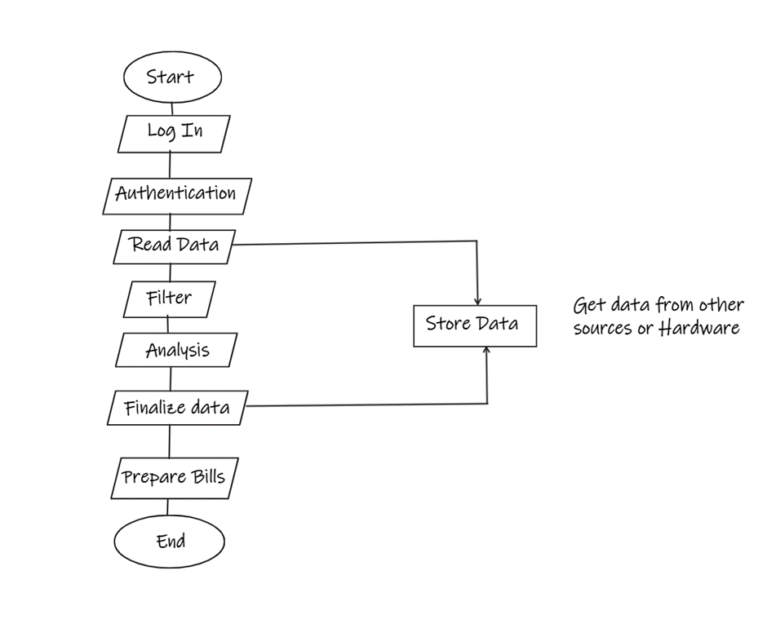

## System Components

### Functions

Preliminary list of all functions in the software. For each function in the list the following information is provided:

* a brief description of what it does (1 or 2 sentences);
* a list of the input parameters, and their data types, and what they are used for;
* a list of any side effects caused by the function (ie change global or member variables, changes data passed by reference from calling function etc)
* a description of the function’s return value
* Hardware is assigned to applications based on their requirements.
* Schedule the programmes on the CPU for linear and methodical execution.
* Memory is assigned to each individual application based on the requirements of the programme.
* Programs' input and output devices are assigned one at a time.
* There, user contact is accomplished by recognising the user's expectations and requirements and reacting to them with a suitable message or task.
* All programme and data files are managed and kept on secondary storage devices.
* The file directories existent in memory are retained, and access to the files' data is granted.
* Maintain software-user coordination by allocating, assigning, and providing assemblers, compilers, memory, interpreters, and other resources.
* Maintaining system security and access privileges to diverse system resources

### Data Structures / Data Sources

List of all data structures in the software (eg linked lists, trees, arrays etc) or eternal data sources. For each data structure in the list the following information is provided:

* Type of structure (tree, list etc),
* Description of where and how it is used
* List of data members, and what each one is for do
* List of functions that use it

Data structures are abstract structures that are arranged in a certain way and are used to organise data and perform different operations on it. Data structures vary in their suitability for various applications, and some are highly specialised to certain tasks.

The Type of structure are:

1. Record: It is a fixed number and sequence and typically indexed by names.
2. Union: It is a data structure that specifies which of several permitted primitive types may be stored in its instances, e.g., float or long integer.
3. Set: It can store specific values with no duplicate value.
4. Graph and a tree: It linked abstract data structures composed of nodes. Each node contains a value and one or more pointers to other nodes arranged in a hierarchy.
5. Class: It contains data fields, like a record, as well as various methods which operate on the contents of the record.

### Detailed Design

Pseudocode for all non-standard / non-trivial algorithms that operate on data structures

The materials engineering perspective is required for the following parts of the detail design phase:

* Choosing bespoke subassemblies and components providers
* Choosing commercially available subassemblies and components
* completing bespoke subassemblies and components design
* Creating manufacturing processes
* Completing requirements for subassemblies, components, materials, and production processes
* Performing product verification tests

# User Interface Design

This is your initial interface design. Describe the tools you used for this design stage and any key findings that informed your design. This introduction is descriptive and should explain what you have completed for the actual design work you will present in the sub-sections below.

First there will be a login page for user to login. Then they will be directed to the home page.

Home page will contain the search bar where they can search any cases or fines form the database. Home page will contain the logo of the company on top-middle of screen. Home page will contain one filter option where user can filter the data according to their needs (for e.g. Time, date or the types of building, suburb). User can go through the available data without searching as well.

## Structural Design

Structural design refers to the navigational and information structure of your product – the structure that supports the interface layout. How will you structure your product? How will you group your information? How will you navigate through your product? Why? This can take the form of a diagram showing structure and hierarchy, supported by a discussion and justification of your choices. Why have you made these design choices? Describe and outline the structure of your interface and of your information.

If software gives a computer the instructions it needs to execute a task, software structure design is the path the programme takes to do so. It's vital to remember that an architectural pattern isn't a finished design that can be plugged in; rather, it's a template that can be manipulated to address issues in a variety of settings.

## Visual Design

Detail your visual design: Layout, visual elements, icons, graphics, style, colour, fonts general screen designs. This can be sketches, wireframes, mockups etc, supported by a discussion, explanation, and justification of your choices.

Top right corner that is user icon which shows who is login and from there user can change their personal details and password also.

There is search bar for user to search particular info they are looking for. And filter bottom to filter the data according to needs.

Bellow the search bar that’s where the data can be found.